cTAKES USDHUB Batch 1 processing report
Dr. Layth Qassem, PharmD, MSACI

cTAKES USDHUB Batch 1 processing report
Run date: July 24-25, 2026
Report date: July 25, 2026
Run ID: ctakes-async-20260724T232510Z-3615680
Wrapper release: 2.1.19_2026AA.r1_6.0.0

Batch 1 result
Batch 1 completed all 1,708,157 notes in 9 hours, 47 minutes, and 21 seconds. The final manifest is complete, the sanity report passed, WSD runtime validation passed, and the current delivery was accepted. The run used the locked USDHUB settings: STAR pipeline, SQLite plus two CSVs, WSD on, strict filenames, and XMI off.
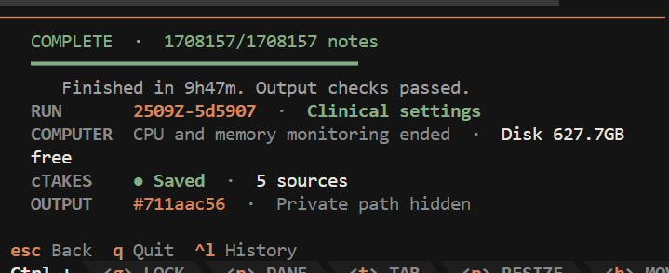
Batch 1 TUI completion screen showing 1,708,157 of 1,708,157 notes complete and output checks passed.
The no-write input check inventoried the complete batch once and finished in about 29 seconds. The accepted recovery contract then split the notes across four async shards, assigned four pipeline threads and a 16,384 MB Java heap ceiling to each shard, and kept the aggregate Java heap ceiling at 65,536 MB. All four workers completed, combined observed memory stayed near 50-52 GB, and 627.7 GB remained free on the output volume after finalization.

Compute and run specification
Specification | Batch 1 value | Evidence boundary
Compute host | CPM2, Linux x86-64 | Run location plus host inspection
CPU capacity | 2 Intel Xeon Silver 4216 sockets at 2.10 GHz; 32 physical cores; 64 logical CPUs | lscpu inspection after the run
Installed memory | 404.7 GB decimal, about 376.9 GiB | free -b inspection after the run
Async shards | 4 | Accepted recovery_contract.json
Pipeline threads | 4 per shard; 16 aggregate | Accepted recovery_contract.json
Java Xmx | 16,384 MB per shard; 65,536 MB aggregate ceiling | Accepted recovery_contract.json
Clinical settings | STAR; SQLite plus two CSVs; WSD on; strict filenames; XMI off | Run manifest and receipt read-back
Software identity | Wrapper 2.1.19_2026AA.r1_6.0.0; Apache cTAKES 6.0.0; UMLS 2026AA | Run manifest and dictionary receipt
The run receipts bind the four-shard plan and exact software assets. The CPU model and installed-memory totals were read from CPM2 after completion because the run manifest does not duplicate the complete host hardware inventory.
Measure | Batch 1
Notes processed | 1,708,157
Distinct HubIDs | 4,996
Average notes per HubID | 342
Processing window | 7h 53m 24s
Processing rate | 60.14 notes/second
Engine wall time | 8h 03m 12s
Post-engine validation and export | 1h 43m 46s
Complete wall time | 9h 47m 21s
Two RegexSpanFinder timeout messages occurred in one worker. They did not stop the worker or the batch, and the final document count still matched the planned count. They remain note-level exceptions to review because a completed batch does not prove that every possible annotation was recovered from those two timed-out regex operations.

Output and receipt checks
The accepted run contains 142,891,564 concept rows and 11,004,425 medication candidate rows. The two CSVs matched the scoped SQLite views during the final read-back check.
Artifact | Approximate size | Status
annotations.sqlite | 81.47 GB | SQLite schema 8, checked
concepts.csv | 19.73 GB | Row and cell parity checked
drugs.csv | 1.53 GB | Row and cell parity checked
run_manifest.json | 8.9 KB | Complete
sanity_report.json | 2.0 KB | Pass, zero errors
wsd_validation.json | 1.0 KB | Runtime pass
The three main data files use about 102.73 GB in total. GB uses decimal storage units, where 1 GB equals 1,000,000,000 bytes.
The completed run keeps concepts.csv and drugs.csv inside the run folder because validation, recovery, and the viewer depend on those fixed canonical names. After the run passes, the wrapper creates one owner-only handoff copy for each logical CSV under named-csv/. Because the selected input folder was batch_1, the automatic Batch 1 handoff is:
named-csv/batch_1--ctakes-async-20260724T232510Z-3615680/
batch_1--ctakes-async-20260724T232510Z-3615680--concepts.csv
batch_1--ctakes-async-20260724T232510Z-3615680--drugs.csv
The wrapper takes batch_1 from the selected notes-folder name and adds the source run ID so separate runs cannot collide. Check output records each logical result once as canonical name to file to send. The automatic name has no handoff timestamp, so a retry verifies the same published bytes or rebuilds an interrupted unpublished staging directory instead of creating another timestamped set. A changed published CSV fails closed and is not overwritten.
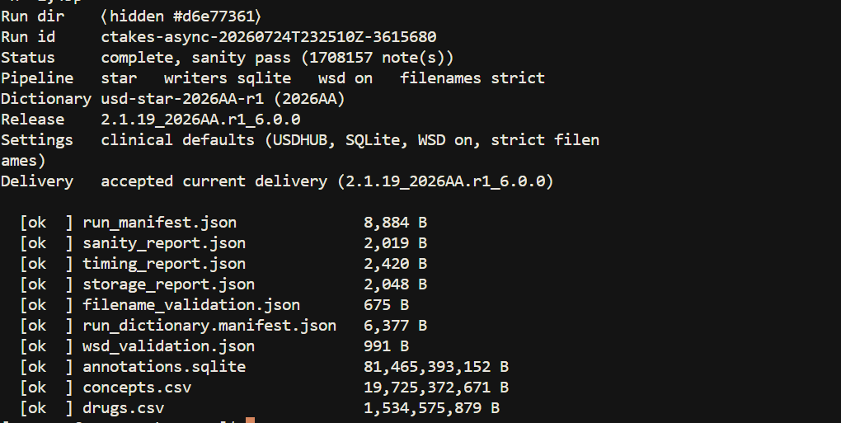
Filtered Batch 1 receipt read-back showing the complete status, accepted delivery, and checked artifacts.
The sanity report passed the manifest, source-integrity, SQLite, WSD, embedded-source, and batch-CSV checks. WSD remains clinically not-evaluated. The runtime receipt proves that the expected model ran and stayed bound to the 2026AA dictionary; it does not establish clinical accuracy.

Kidney-stone extraction readout
The NIH project USDHub: community resource for Urinary Stone Disease research, project 1RC2DK140865-01, includes an aim to enrich USDHub with information extracted from CT images and clinical notes using NLP and machine learning. This first readout checks whether the completed cTAKES batch contains the expected urinary-stone signal and related clinical concepts. It is an extraction inventory, not a phenotype validation or prevalence estimate.
The direct-stone set used four UMLS CUIs:
- C0022650, kidney calculi;
- C0392525, kidney stone or nephrolithiasis;
- C0041952, ureterolithiasis; and
- C0451641, urolithiasis.
NCBI MedGen documents the kidney-stone, ureterolithiasis, and urolithiasis concept mappings used for this preliminary set.
Direct urinary-stone measure | Count
Candidate mentions | 178,146
Notes with at least one core CUI | 104,728
Notes with at least one core CUI not marked negated | 101,669
Notes containing only negated core-CUI mentions | 3,059
HubIDs with at least one core CUI | 4,548 of 4,996, or 91.0%
HubIDs with at least one core CUI not marked negated | 4,485 of 4,996, or 89.8%
The person-level coverage is consistent with a urinary-stone cohort, while only 6.1% of all notes contain one of the four core CUIs. That difference matters because the batch averages 342 notes per HubID. A patient-level history cannot count each note or each repeated answer as a separate event.

Concepts inside direct-stone notes
The table below is restricted to the 104,728 notes containing at least one core urinary-stone CUI. Not negated means cTAKES did not assign negative polarity to at least one mention. It includes blank or unassigned polarity and must not be read as a confirmed diagnosis.
Related concept | Notes | Notes not marked negated | HubIDs | HubIDs not marked negated
Hematuria | 23,110 | 17,219 | 3,081 | 2,642
Flank pain | 13,801 | 11,816 | 2,777 | 2,592
Hydronephrosis | 17,578 | 8,747 | 3,131 | 1,929
Nephrocalcinosis | 728 | 725 | 105 | 103
Urinary tract infection | 8,307 | 7,853 | 1,155 | 1,100
Pyelonephritis | 3,485 | 3,347 | 766 | 720
Acute pyelonephritis | 271 | 268 | 64 | 62
Chronic kidney disease | 7,194 | 7,134 | 514 | 502
Hypertension | 47,111 | 46,679 | 2,717 | 2,652
Fracture | 12,921 | 11,852 | 1,342 | 1,112
The symptom and obstruction signals, including hematuria, flank pain, and hydronephrosis, are visible at useful scale. Infection concepts are also present. Chronic kidney disease, hypertension, and fracture appear in the same stone-note subset, which matches morbidity domains named in the NIH project abstract, but these are co-occurrences. This pass does not prove that the stone caused the other condition, that both concepts refer to the patient, or that they belong to the same episode.
An exact lookup for acute kidney injury CUI C2609414 returned zero rows in this narrow code set. That does not establish that acute kidney injury is absent. The next pass needs an expanded CUI and synonym set before that variable can be evaluated.
The most common raw co-occurring concepts included generic rows such as stone, kidney, history, and pain. This is expected from a candidate-preserving cTAKES output, but it shows why the 142.9 million rows cannot be treated as finished research variables.

Aggregate method
The preliminary analysis opened the accepted SQLite file in immutable read-only mode and selected only aggregate fields from run_metadata, documents, cui_counts, and terminology columns in concepts.
- No source note text was selected.
- No HubID, NoteID, filename, path, or row-level clinical value was printed or copied into this report.
- HubIDs were used only inside COUNT(DISTINCT ...).
- Direct-stone notes were defined by the four listed CUIs.
- Related-concept counts were limited to those direct-stone notes.
- Counts overlap because one note and one HubID can contain several concepts.
- Raw cTAKES concepts remain candidates. Negation, subject, uncertainty, conditionality, temporality, note type, and duplicate longitudinal mentions still require review.

Patient-level variable pass
The next analysis should turn the candidate rows into reviewable longitudinal variables:
- Group notes by HubID and order them by the approved note date.
- Separate current, historical, negated, uncertain, conditional, generic, family, and other-subject mentions.
- Collapse repeated answers without collapsing separate symptomatic stone events.
- Build discrete variables for stone history, recurrence, location and laterality, obstruction, infection, procedures, stone composition, and 24-hour urine findings.
- Keep conflicting evidence visible instead of forcing one answer.
- Validate each variable on a locked clinician-reviewed sample before cohort use.

Browser-to-shell and ClickFix control
The current README, install guide, troubleshooting guide, release notes, public TUI walkthrough, and versioned Word MOP use a split trust sequence. The first command clones source without running repository code. A second command uses local Git to require the exact Codeberg remote, expected source reference, and a clean checkout. Setup and ./ctakes run only in the third step after that check passes.
The public site has no shell-command Copy button and no JavaScript path that writes any site content to the clipboard. Commands and CSV examples remain visible and manually selectable. Automated site checks fail if clipboard-writing code returns or if the public clone command also runs setup.sh or ./ctakes.
This control closes the official site’s browser-to-shell clipboard substitution path and removes the clone-and-immediately-execute chain. It cannot make a compromised source repository, local Git executable, browser, or manually selected unrelated command trustworthy. Those remain separate supply-chain and endpoint controls. The TUI itself does not use a hidden clipboard command for installation, verification, repair, or update.

