STAR MOP
Phase I: Notes extraction

Step 1. Kidney stone cohort identification
The kidney stone cohort has been identified and assigned with USDHub IDs. An example of the USDHub ID format has “USDHUB+20 digits” (An example: USDHUB12345678901234567890). Your site has been provided a mapping between a local patient ID (usually a PCORnet ID or pseudoID) and USDHub IDs.

Step 2. Note identification
For each patient in the USDHub cohort, your site should extract all associated clinical notes corresponding to one of the six note types:
- Admission note
- Discharge summary
- Inpatient note
- Outpatient note
- Radiology report
- Emergency department note

Notes:
- If your EHR system follows the OMOP Common Data Model (CDM) format, the note types should be identified using the note_type_concept_id field. The concept ID values for each of the 6 note types are listed below.
note_type_concept_id | note_type_concept_name
44814637 | Discharge summary
44814638 | Admission note
44814639 | Inpatient note
44814640 | Outpatient note
44814641 | Radiology report
44814646 | Emergency department note

- If your EHR system does not follow the OMOP CDM structure, it is recommended to extract all available notes for cTAKES processing to reduce the risk of omitting clinically relevant note types (e.g., operative or radiology reports). Alternatively, a site-specific note-type classifier may be used, provided it demonstrates high classification accuracy.

OMOP CDM links:
- high overview of OMOP CDM (see figure below with the organization of the tables): https://ohdsi.github.io/CommonDataModel/index.html
- standardized note types in the CDM Concept table: https://athena.ohdsi.org/search-terms/terms?conceptClass=Note+Type
- latest version of CDM: https://ohdsi.github.io/CommonDataModel/cdm54.html
- latest version of Notes table in CDM: https://ohdsi.github.io/CommonDataModel/cdm54.html#note

Step 3. Clinical note data elements for extraction
For each identified note, the following data elements should be extracted into a local file system:

Data element | CDM field | PCORnet field | Requirements
Patient ID | person_id | patid | not null
Note ID | note_id | note_id | not null
Note date | note_date | note_date
Note type | note_type_concept_id | note_type
Note title | note_title | note_title
Visit occurrence ID | visit_occurrence_id | encounterid
Provider ID | provider_id | provider_id
Note content | note_text | note_text | not null

Notes:
- Please note that de-identification of the notes (i.e., removal of HIPAA identifiers) is not required for this task. If your institution has internal requirements for this, then it is also ok to do.
- Note titles may need to be de-identified if they are not standardized.

Step 4. Storage of note data elements
- Each note content should be stored locally into a file with the following name format: USDHubID.NoteID.txt

- The rest of the data elements should be stored into a csv file with the following columns: USDHubID,NoteID,NoteDate,NoteType,NoteTitle,VisitOccurrenceID,ProviderID

October 31, 2025

Notes:
- USDHubIDs should be assigned based on the established mapping between patient IDs and USDHub IDs.
- USDHub IDs must be in the correct string format: An example of the USDHub ID format has “USDHUB+20 digits” (An example: USDHUB12345678901234567890).
- It is recommended that note content files be stored in batches, with each batch organized into a separate folder.

Phase II: Run cTAKES with the TUI
Use this workflow after Phase I notes have been prepared. The TUI checks filenames, capacity, storage, run progress, and final output before anything is handed off.
What you deliver
Deliver only concepts.csv and drugs.csv for the routine approved handoff.
Keep annotations.sqlite, JSON receipts, logs, manifests, optional XMI or browser HTML, prepared-note receipts, and named-copy receipts inside the approved local environment. They support validation, audit, review, and recovery; do not send them unless the project lead explicitly requests them and the transfer is approved.
Never hand off partial output. Send the two CSVs only after the TUI says the output passed all checks.

Start-to-finish directions

1. Clone, verify, then install
Use Linux or WSL with Git and Java 17 or newer. Python 3.9 or newer is supported. The installer chooses the newest supported Python already available, creates a private environment for the TUI, and does not replace the system Python.
Command safety: The official site has no shell-command Copy button and no code that writes commands to the clipboard. Select visible text manually. This guide never asks you to paste a command from a browser verification box, CAPTCHA, pop-up, Run dialog, chat, or support message. If anything does, stop. Run the next three steps separately so cloning ends before repository code can execute.
A. Clone only. This downloads the checkout and does not run its scripts.
git clone --branch main --depth 1 https://codeberg.org/editnori/Ctakes_USD.git Ctakes_USD
B. Use local Git to require the exact Codeberg remote, main branch, and clean working tree. A pass prints Verified clean main checkout and the commit ID. No output or an error means stop.
test "$(git -C Ctakes_USD remote get-url origin)" = "https://codeberg.org/editnori/Ctakes_USD.git" && test "$(git -C Ctakes_USD branch --show-current)" = "main" && test -z "$(git -C Ctakes_USD status --porcelain)" && printf 'Verified clean main checkout: ' && git -C Ctakes_USD rev-parse --short=12 HEAD
C. Only after the local check passes, run setup, the known-answer test, and the TUI.
cd Ctakes_USD && bash scripts/setup.sh --tui && ./ctakes verify && ./ctakes tui
Continue only after verification prints: PASS: cTAKES USDHUB is ready for a full batch.
Later, reopen the console with ctakes tui. From the repository folder, ./ctakes tui also works.

2. Confirm the console is ready
On the Home screen, verify that Setup, System diagnostics, and Sample testing passed and that the banner says READY TO PROCESS NOTES.
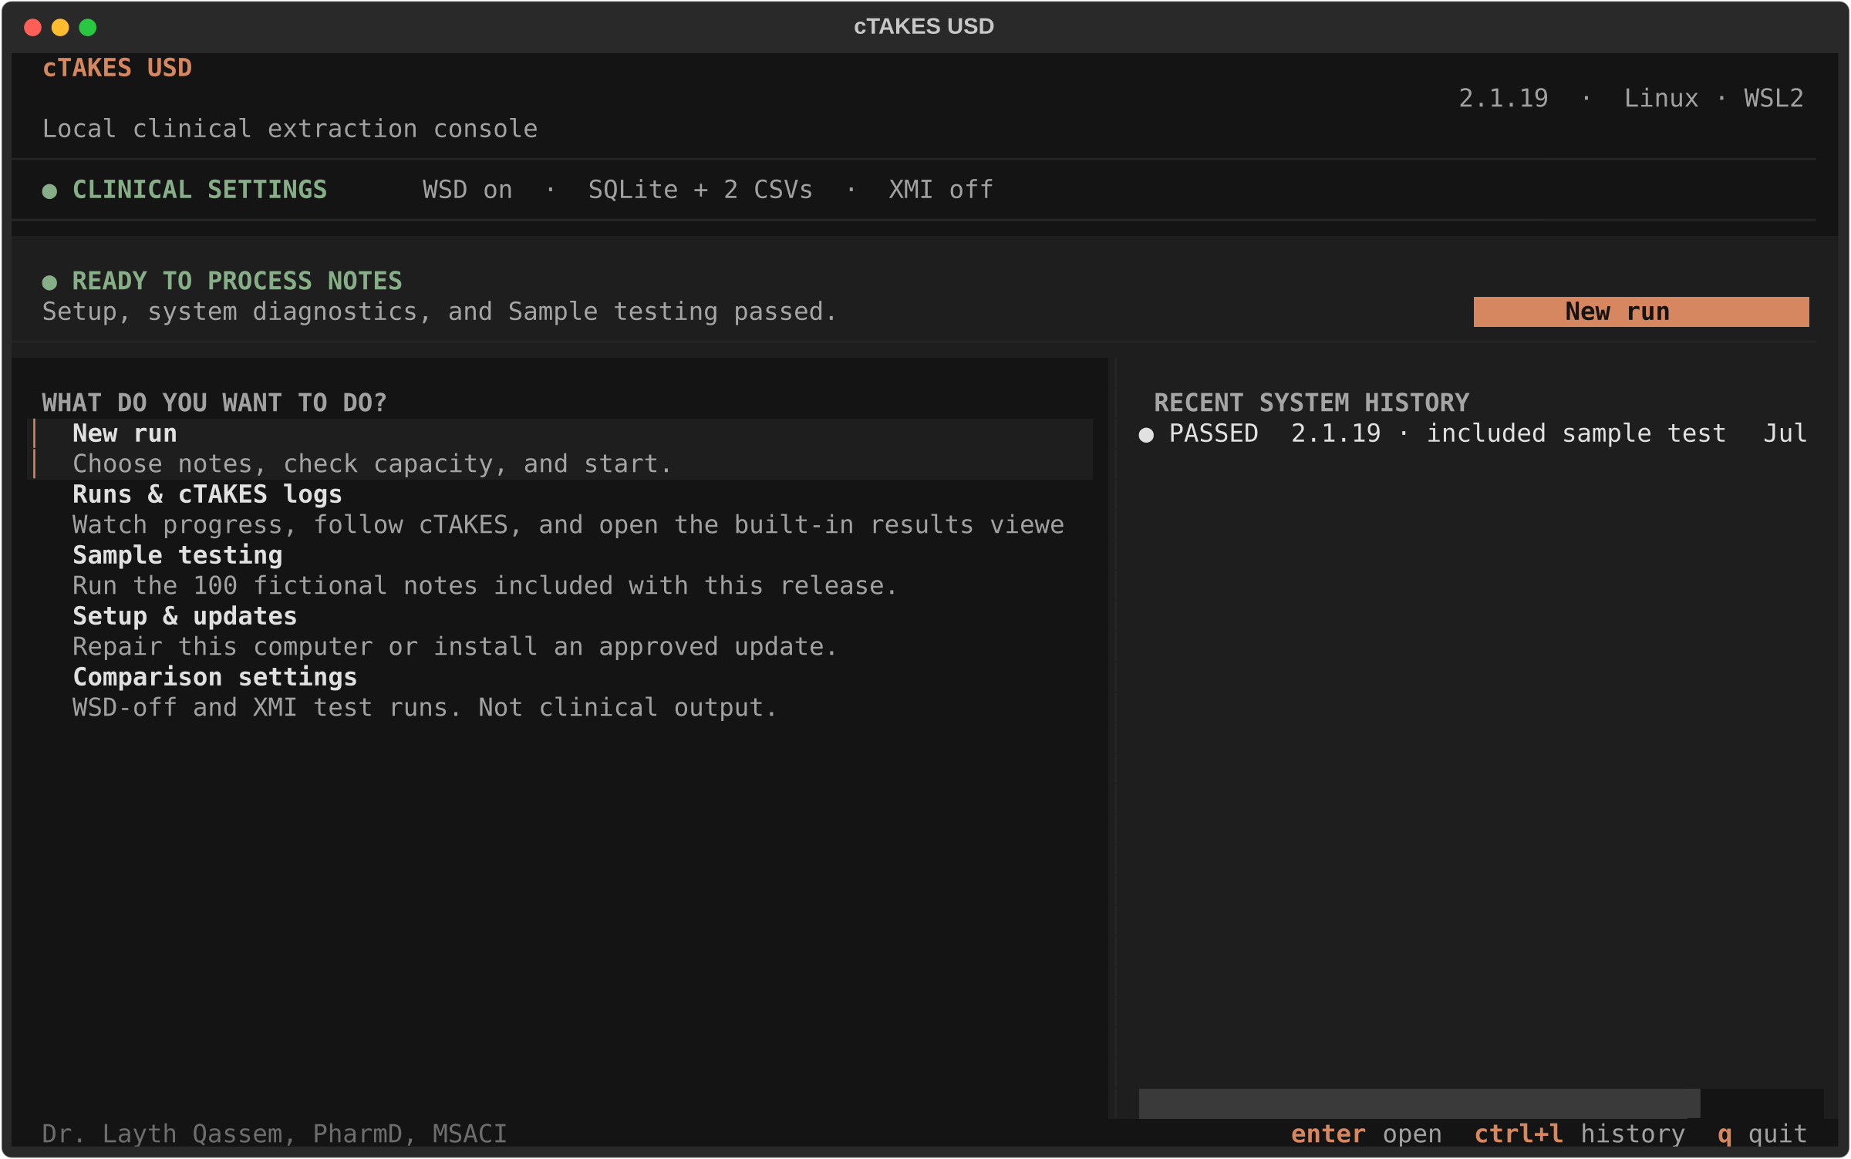
Figure 1. Confirm that the Home screen says READY TO PROCESS NOTES.

3. Choose the notes and results folders
Select New run. Choose the folder containing the approved .txt notes, then choose where the private results will be saved. Subfolders are allowed, but the notes folder itself must contain only supported .txt notes.
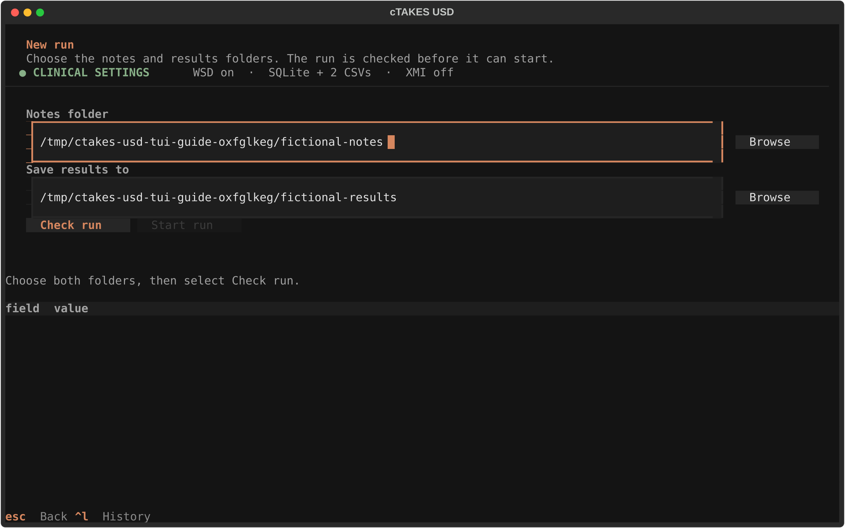
Figure 2. Open New run, then select the notes folder and the results location.

4. Check the run before starting
Select Check run. Review the note count, filename validation, computer capacity, and storage estimate. If names are convertible, use Prepare compatible copy, then choose Use prepared folder and re-check. The original notes are never renamed in place.
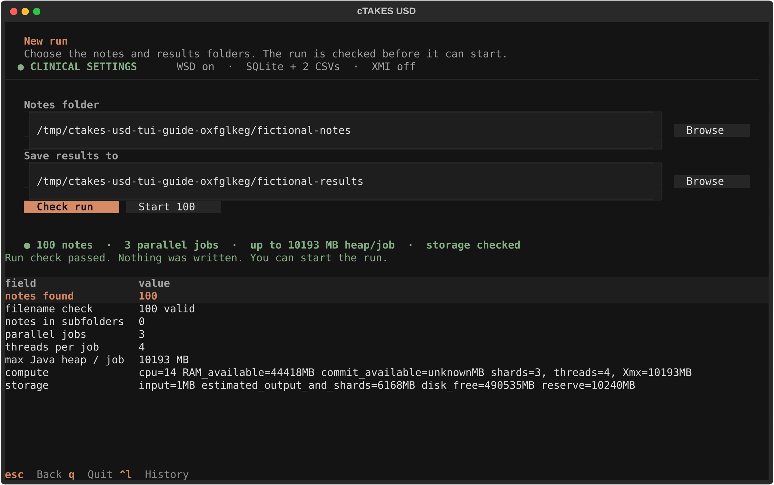
Figure 3. Select Check run and review the note, filename, capacity, and storage checks.

5. Start the background run
Select Start N notes, review the confirmation, and select Start. Wait until the console reports Started before closing the TUI or the SSH terminal. After that message, the managed run continues in the background.
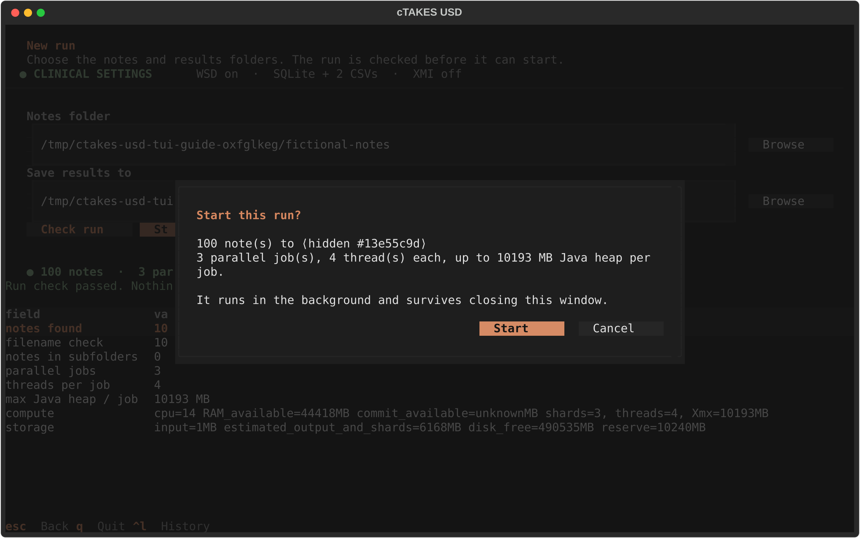
Figure 4. Review the confirmation, then start the background run.

6. Monitor and reconnect
Open Runs & cTAKES logs to follow the current stage. You may leave and reopen the TUI; it reconnects to the saved background run. If a sharded run is interrupted, select Check & continue and review the recovery preview before confirming.
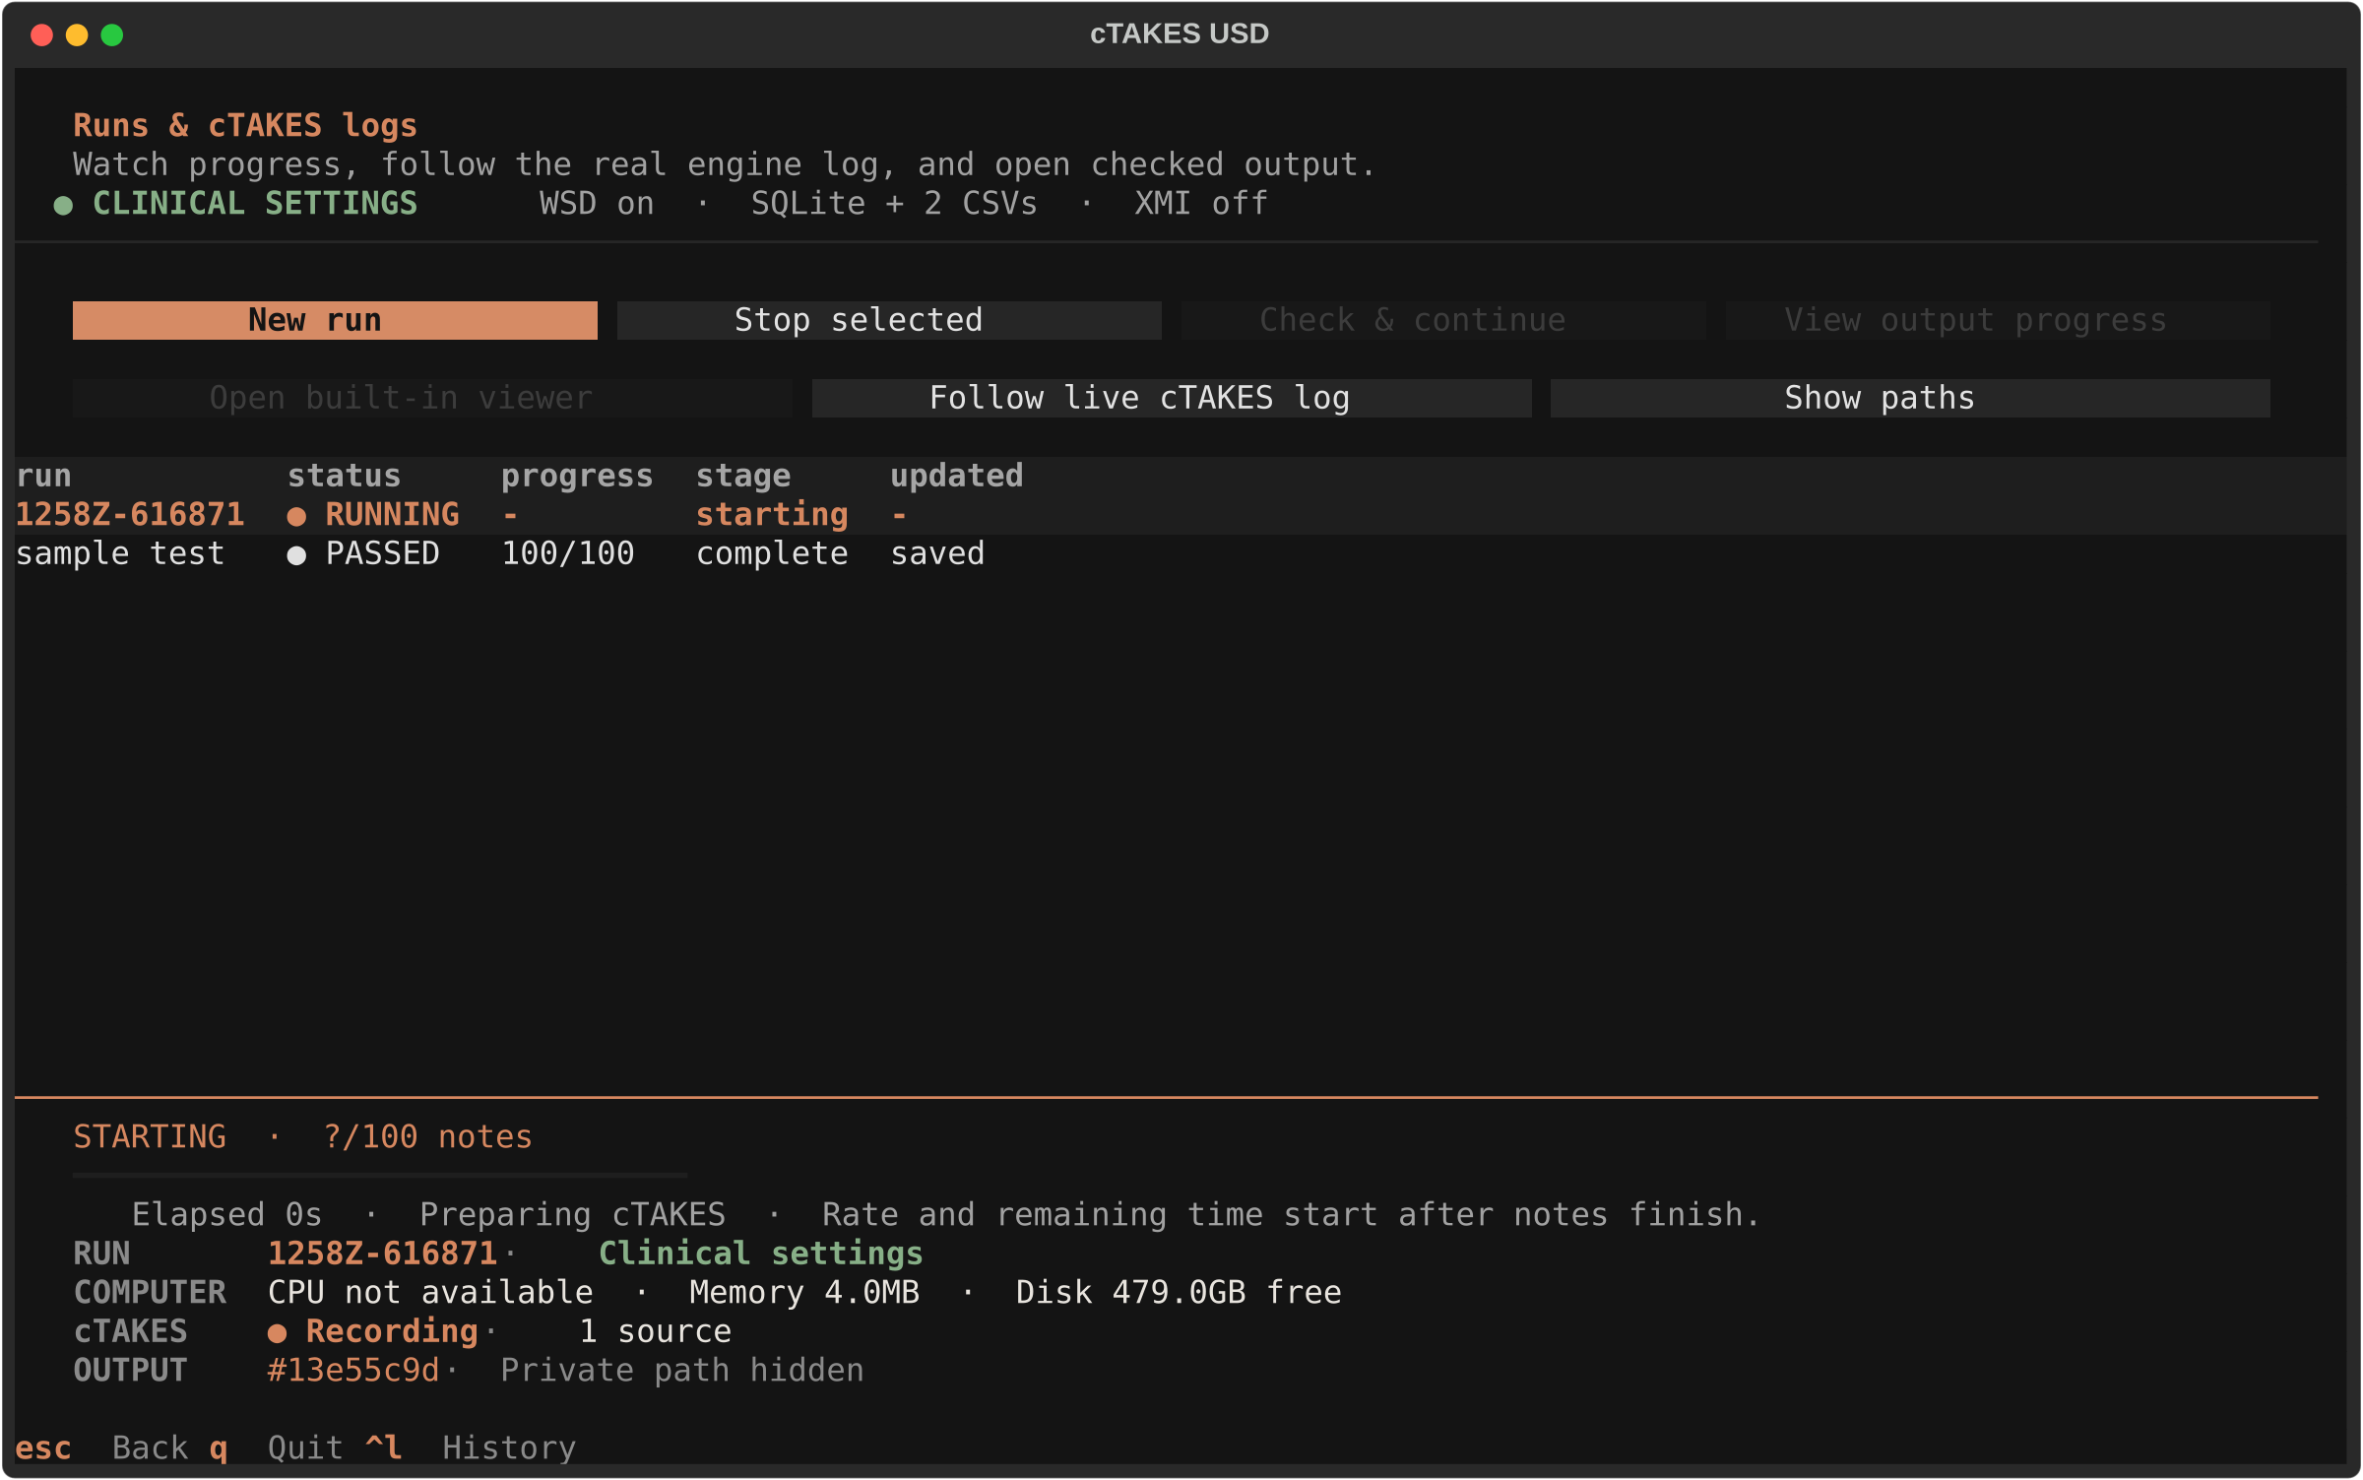
Figure 5. Use Runs & cTAKES logs to follow processing without keeping the TUI open.

7. Wait until the run passes
Wait until the run is complete and the console says OUTPUT PASSED ALL CHECKS. The CSV files are ready for the approved handoff. Failed, stopped, or partial output must stay local and must not be sent.
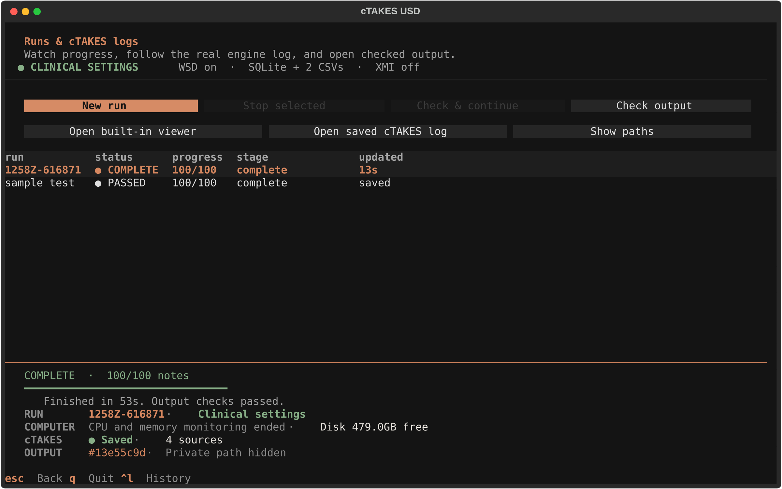
Figure 6. Wait for the run and its output checks to pass.

8. Review locally
Open the built-in viewer to review source text, concepts, and medications. The viewer and SQLite database can contain full note text and must remain inside the approved clinical environment.
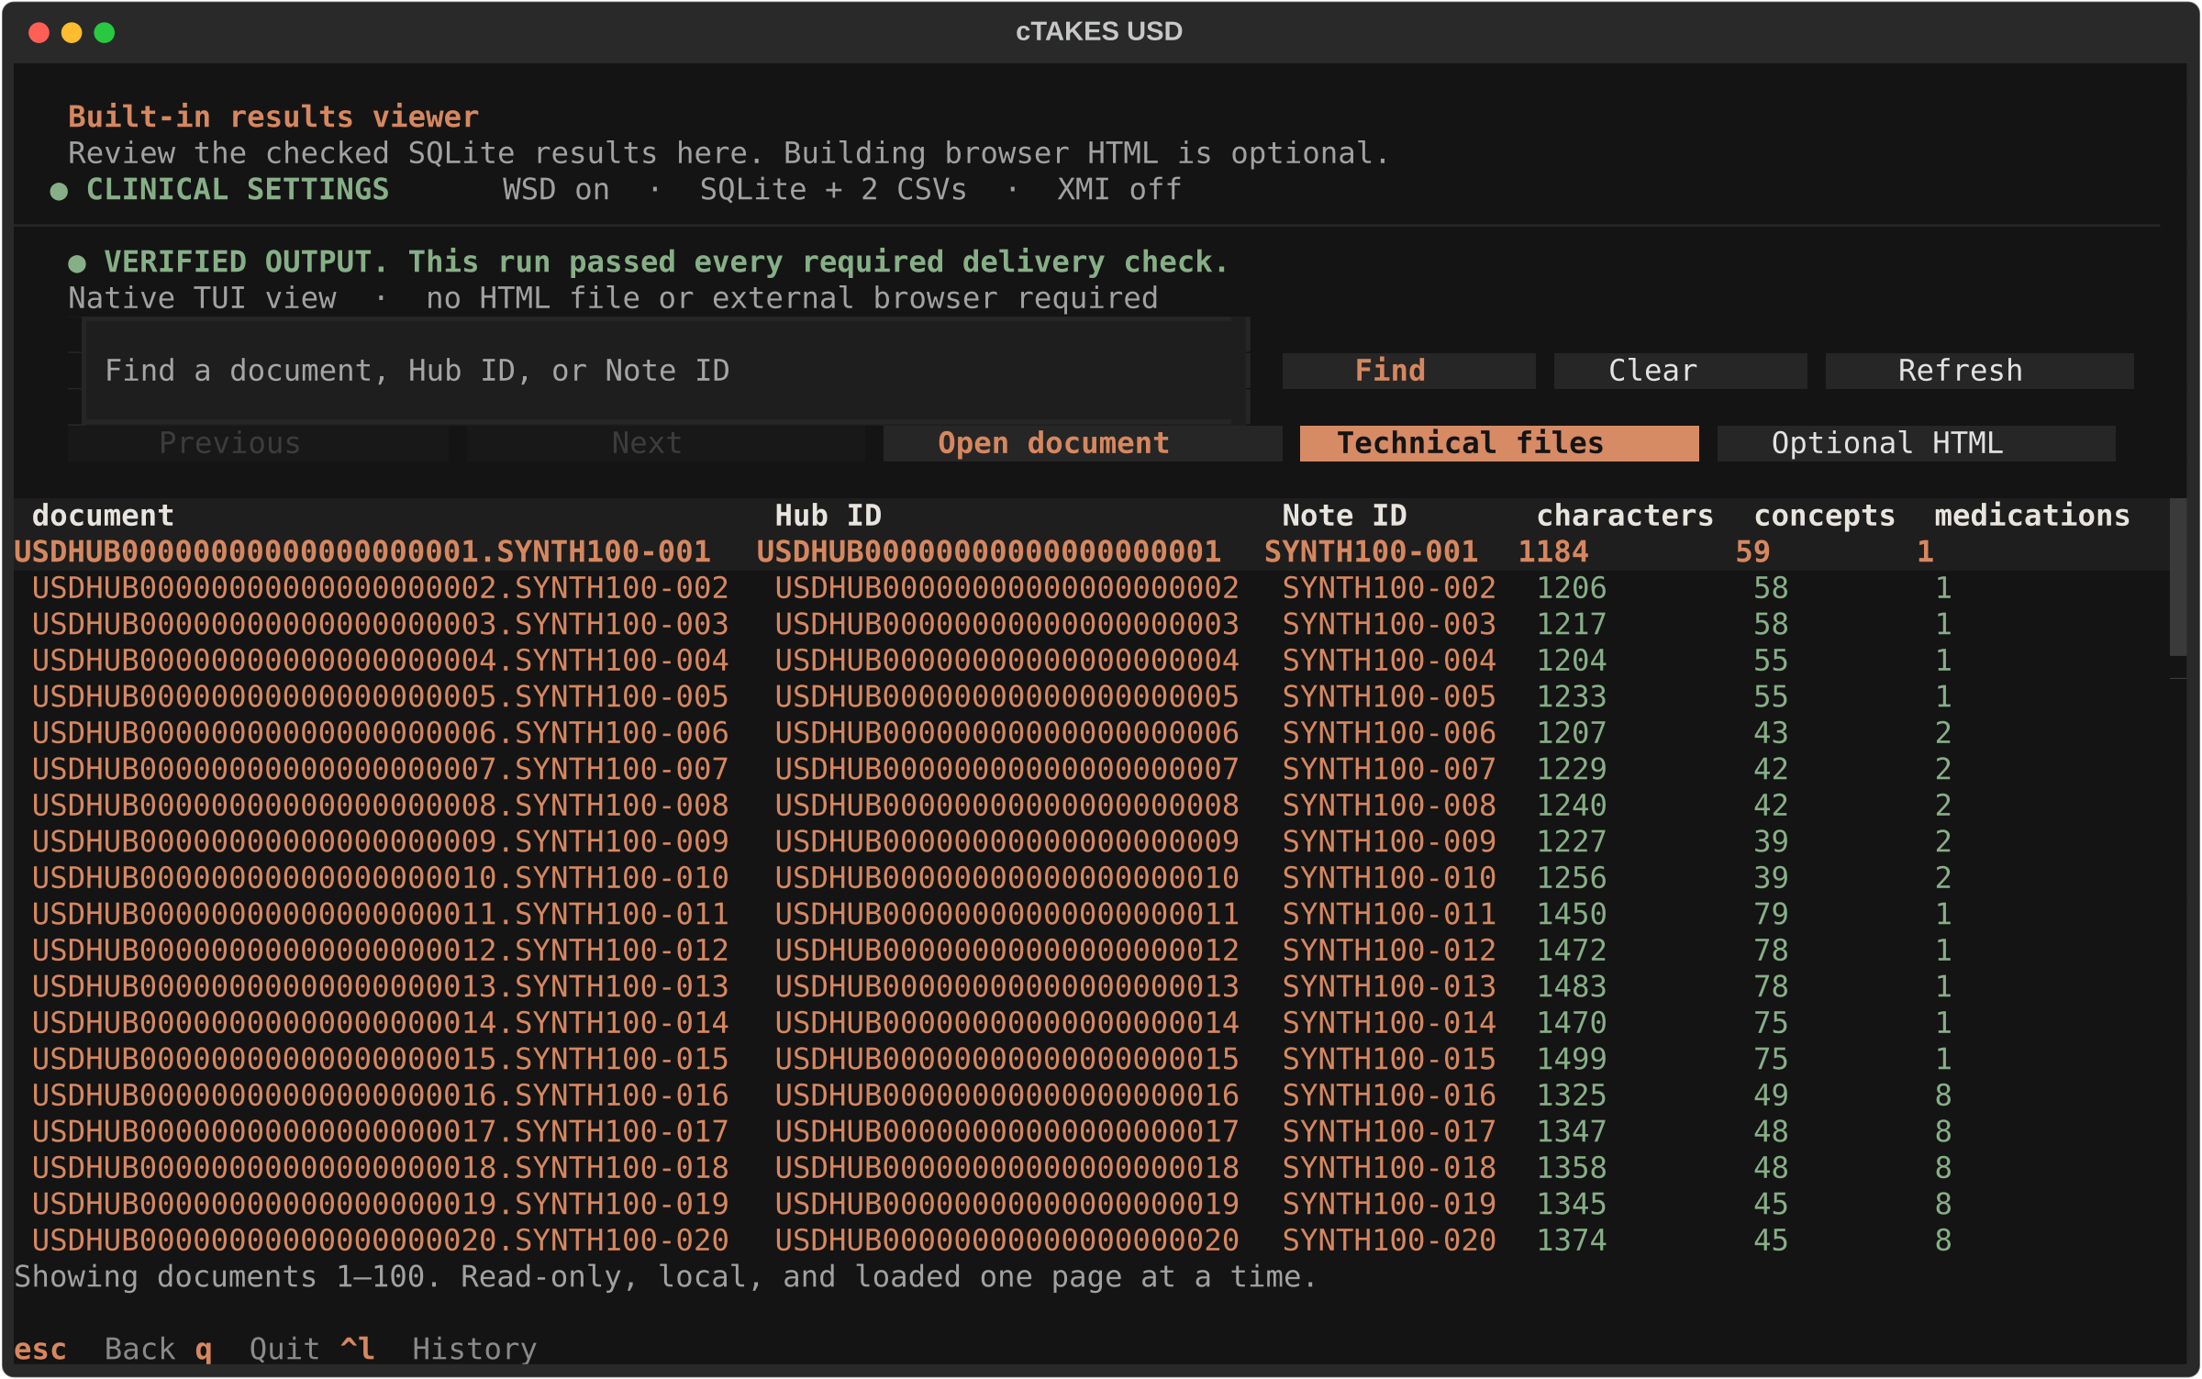
Figure 7. Open the built-in viewer for a local clinical review.

9. Read the exact two handoff filenames
After the run passes, the controller creates one owner-only hashed handoff copy for each logical CSV. The filenames begin with the notes folder name and source run ID. Notes staged with Prepare compatible copy use the results folder name instead. Nothing is uploaded or sent. Open Check output. It shows concepts.csv (canonical) beside the exact folder-named concepts file to send, then shows the same mapping for drugs.csv. Send the two names on the right. Technical files remains the local artifact viewer and reports AUTOMATIC CSV COPIES READY without repeating the handoff names. Retry automatic CSV copies appears only when the automatic copy needs attention; Prepare automatic CSV copies is for a verified older run without that record. The canonical CSVs remain unchanged for validation, recovery, and local review.
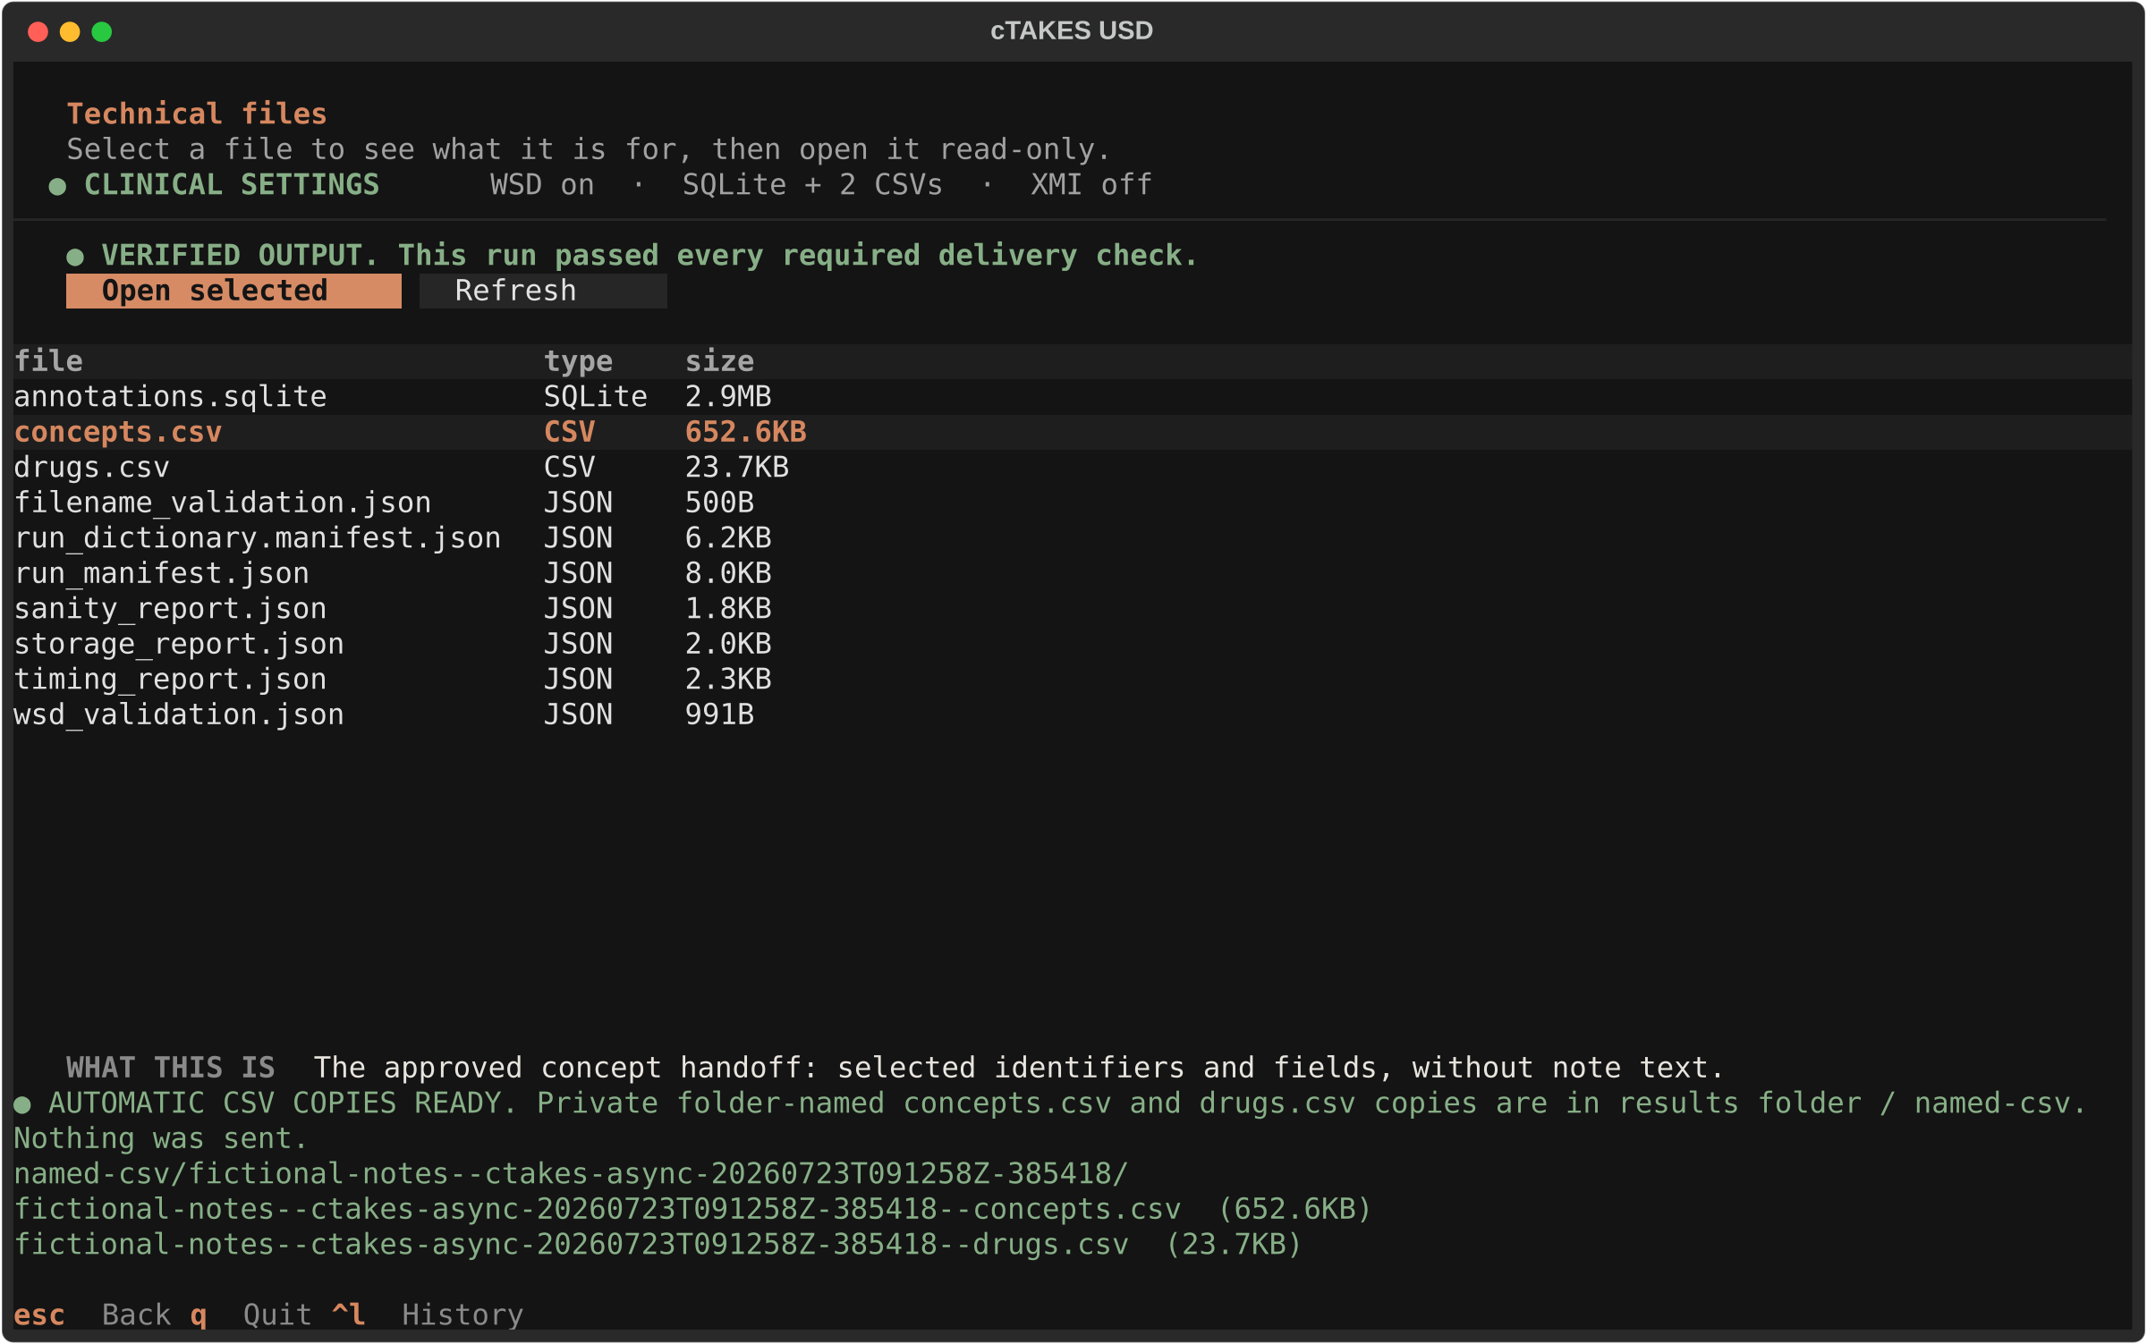
Figure 8. Open Technical files to review the canonical CSVs, receipts, and local audit artifacts.
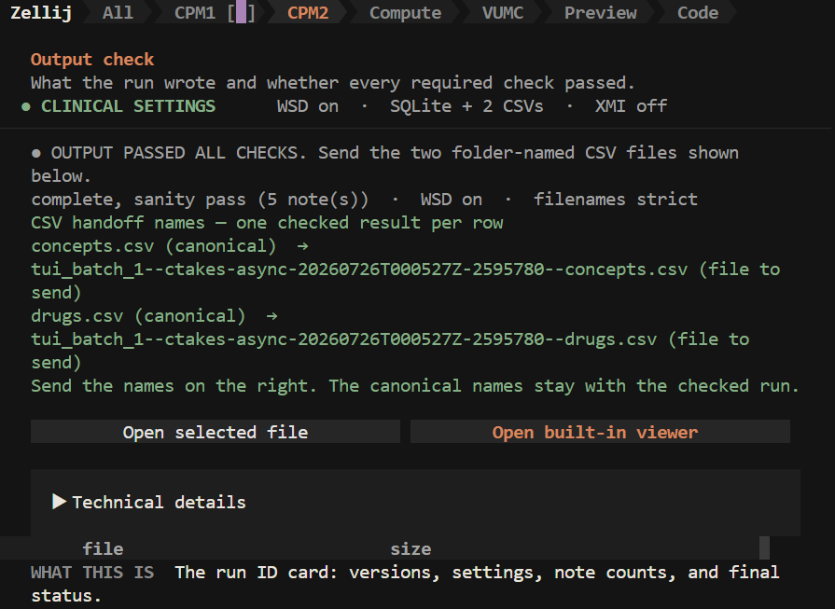
Figure 9. Open Check output and read each canonical CSV role beside its exact folder-named file to send.

Files to deliver
File | What it contains | Routine handoff
concepts.csv | Approved concept extract: 13 selected columns | Deliver
drugs.csv | Approved medication/RxNorm extract: 16 selected columns | Deliver
annotations.sqlite | Local checked database; powers the viewer and validation | Keep local
Receipts, logs, manifests | Run identity, hashes, checks, and troubleshooting evidence | Keep local
Optional XMI or browser HTML | Comparison/review artifacts that can include full note text | Keep local
Routine handoff: concepts.csv and drugs.csv only. All other artifacts stay local for validation, audit, traceability, review, or recovery unless they are explicitly requested and approved.

Current online guide
The public walkthrough has the same numbered directions and full-size screenshots: https://ctakesusd.dev/tui-guide/. Installation source and release notes: Codeberg cTAKES USD.

